** **

**Northern Ireland Human Trafficking Action Plan 2013 - 14**

**PROGRESS REPORT**

**Background**

In May 2013, the Justice Minister, David Ford, published the first Human Trafficking Action Plan for Northern Ireland. The plan was widely welcomed as a positive step forward, to deliver a coordinated and strategic attack on human trafficking in Northern Ireland.

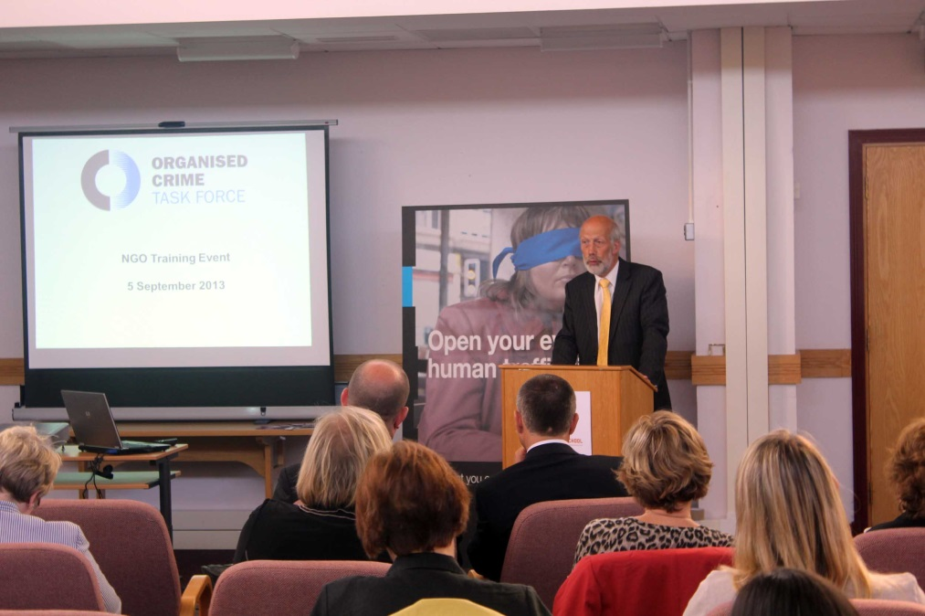

*Minister of Justice addresses attendees at a training event on human trafficking*

2. The action plan identified key objectives across a range of areas that had been identified as priorities for action. In bringing forward this plan, the Minister was clear about the enormity of the challenge of dealing effectively with such a hidden crime. Through the 2013-14 plan we have sought to lay essential ground work in respect of:

* **prevention** – ensuring that our criminal law is compliant with international standards and acts as an effective deterrent; and that key sectors and the wider community are equipped to recognise and report suspicious activity;
* **training** – ensuring that frontline professionals and civil society organisations act from an informed basis and are trained to recognise and respond appropriately and effectively;
* **support and protection for victims** – ensuring that adequate support mechanisms and structures are in place, that information for victims is available and accessible and that there is a victim-centred criminal justice system;
* **investigation and prosecution** – ensuring an effective joined-up response from law enforcement and prosecutors so that perpetrators can be brought to justice through the courts; and
* **understanding trends in human trafficking** – improving our understanding of the scale and impact of human trafficking in Northern Ireland, in order to inform the development of effective operational and policy responses.

**Progress through partnership**

3. The nature of human trafficking is such that it cannot be tackled alone. It requires a joined up response across all levels of Government, statutory agencies and civil society. The Department is grateful for the work of delivery partners

represented on the Immigration and Human Trafficking subgroup of the Organised Crime Task Force (OCTF); on the Human Trafficking Engagement Group; and in local government who have helped to drive forward progress against this action plan.

4. The Engagement Group, and its three subgroups which focus on Education, Awareness and Training, have demonstrated what can be achieved when we recognise and pool the strengths of individuals and organisations into a collective response. The wider reach of civil society groups and of local government has enabled us to raise awareness of human trafficking more effectively across Northern Ireland and, crucially, to provide support and protection to victims and potential victims.

5. Through statutory partners on the OCTF subgroup, improvements have been made to victims’ experiences of the criminal justice system and training and awareness has been rolled out to the key frontline staff who can make a difference in the lives of victims.

6. We have also been working with partners in other jurisdictions towards a consistent, strategic response to the trafficking of human beings. An Garda Siochana is represented on the OCTF subgroup and, throughout the year we have collaborated on a number of initiatives with the Irish Department of Justice and Equality, including co-hosting a cross-border Forum on Human Trafficking, which focused on the identification of victims and on reducing demand.

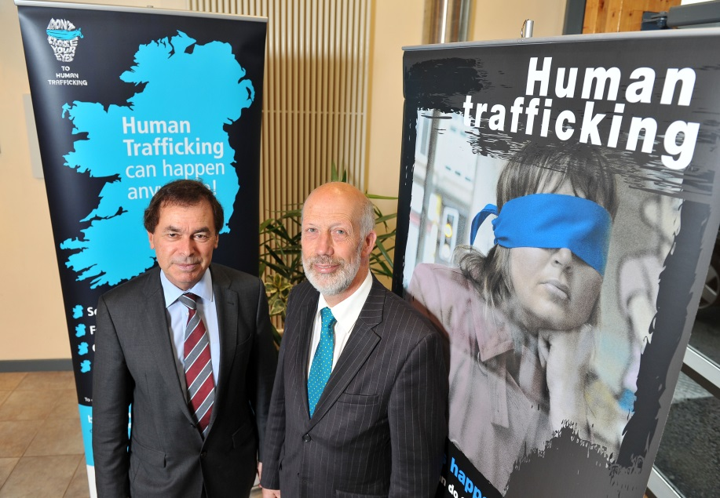

*Minister of Justice with former Irish Justice and Equality Minister at Cross Border Forum on human trafficking*

**Overview of key developments in 2013-14**

7. The 2013-14 action plan has provided a strategic way forward in tackling the horrendous crime of human trafficking in Northern Ireland. Good progress has been made in the course of the year with a number of important developments delivered.

*Legislation*

8. The Criminal Justice (Northern Ireland) Act 2013 included new measures to tackle human trafficking. It brought Northern Ireland’s criminal law into line with the EU Directive on human trafficking, creating new offences and addressing the international dimension of human trafficking. It has also ensured that human trafficking offences in Northern Ireland can now be tried on indictment only, and as such, can be referred to the Court of Appeal by the Director of Public Prosecutions if a sentence is considered to be unduly lenient.

9. The Department has also been working constructively with Lord Morrow to agree amendments to the Human Trafficking and Exploitation (Further Provisions and Support for Victims) Bill, which is currently before the Northern Ireland Assembly.

10. The Minister is committed to ensuring that Northern Ireland’s arrangements for tackling trafficking and those who perpetrate it are as robust as possible. In January 2014, he launched a consultation on new proposals to further strengthen Northern Ireland’s response to trafficking and slavery-like offences. The consultation period closed on 15 April 2014 and the Minister is currently considering the responses, with a view to bringing forward any resultant new legislation during the 2014-15 period.

*Prevention*

11. Prevention has been a key element of our work over the past year and one which has benefitted greatly from the partnership approach that has been adopted.

12. In August 2013 the Minister launched an educational resource on human trafficking for teachers of Year 10 and Key Stage 4, which was developed by Freedom Acts, with the support of the Engagement Group. The pack aims to raise awareness of the issue of human trafficking; to help young people to make healthy, safe choices; and to motivate them to become active citizens in the fight against trafficking. The resource has been made available to all post primary schools in Northern Ireland and we are grateful to local branches of Soroptimist International Northern Ireland for hosting a number of events to promote the resource with teachers. We plan to conduct an evaluation exercise at the end of this academic year.

13. Building on this, the Department also launched an initiative to encourage schools across Northern Ireland to mark EU Anti-Trafficking Day in October 2013. Over twenty schools and Further and Higher Education Colleges, from across Northern Ireland held creative and innovative events to raise awareness of the issue of human trafficking.

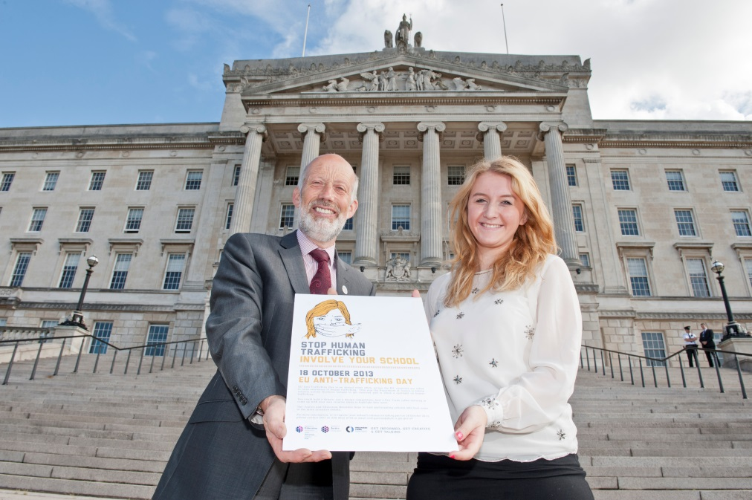

*Minister of Justice with school pupil, promoting education on human trafficking*

14. Human trafficking is a clandestine crime and so, by nature, it is difficult to detect. Raising public awareness so that people across Northern Ireland are able to spot the signs of trafficking and know how to respond safely where they have suspicions, has been an important element to our strategic response. We acknowledge and greatly value the vast amount of work that our partners on the Engagement Group have taken forward, both collectively and individually, in order to engage public interest and raise awareness of trafficking signs and indicators.

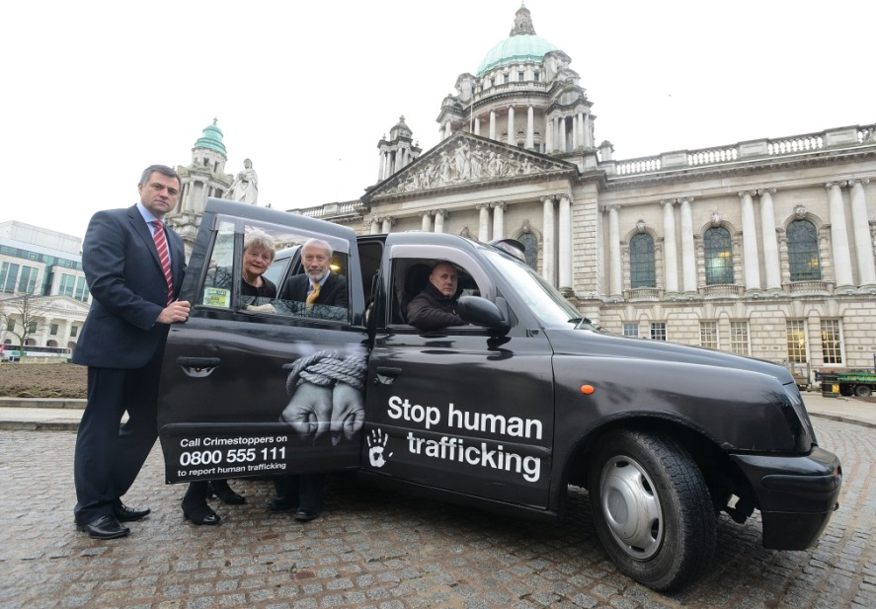

*Raising awareness of human trafficking in partnership with Belfast PCSP*

15. Through the Engagement Group’s Awareness Subgroup we have also identified key sectors for more targeted engagement and were grateful for the opportunity to participate, along with the PSNI and Engagement Group members, in an event hosted by the Belfast Policing and Community Safety Partnership (PCSP) in January 2014. This event provided a forum to engage with Council staff, the hospitality sector, landlords and estate agents and taxi drivers. We believe that individuals working in these sectors may be particularly likely to come into contact with victims of human trafficking and we hope to build on and develop this type of targeted engagement in the 2014-15 year.

*Training*

16. The importance of effective training for those who may come into contact with victims of human trafficking, or who are tasked with roles around recovery, support, investigation or prosecution was also identified as a priority in the 2013-14 plan.

17. Again, whilst we acknowledge that this will continue to be a key priority moving forward, nonetheless good progress has been made to date, including the provision of training to over 4000 PSNI officers; the development of a Training Needs Analysis for statutory bodies represented on the OCTF subgroup; the development by the Health and Social Care Board (HSCB) of guidance for staff in emergency departments; and the delivery of multi-agency training on issues relating to human trafficking to civil society organisations.

*Support and protection for victims*

18. During the 2013-14 period 38 potential victims of human trafficking were recovered in Northern Ireland. The Minister is committed to ensuring that these individuals and others like them, who have been referred into the National Referral Mechanism (NRM) from Northern Ireland, are properly supported. In January 2014, following a public procurement process, DOJ  awarded contracts for the delivery of support services to potential adult victims of human trafficking to Migrant Help in respect of male potential victims and to Belfast and Lisburn Women's Aid in respect of female potential victims.

19. The support package includes, as required, access to safe accommodation and material assistance for victims of human trafficking. It also provides help to access specialised care including medical treatment, psychological assistance, counseling and information. Potential adult victims are also provided with assistance to access translation, interpretation and legal services and provided with help to access compensation. The Department has also produced a multi-lingual leaflet for victims to inform them of their rights and entitlements and has worked with members of the Engagement Group to distribute the leaflets across Northern Ireland in accessible points.

20. The Department is currently working with Lord Morrow to put this support on a statutory footing, through the Human Trafficking and Exploitation (Further Provisions and Support for Victims) Bill.

21. Wider initiatives across the criminal justice system, such as the development and roll-out of Victim and Witness Care Units in courts are helping to ensure that victims are supported through their engagement with the criminal justice system.

22. We also welcome the establishment of the Law Centre (NI)’s Anti-Trafficking and Young People Project, which was launched in September 2013 with funding from Comic Relief. Within the Project, the anti-trafficking legal and policy adviser provides specialist legal advice and representation to victims of trafficking who are under 25 years old and ensures these young people access the appropriate support services via referrals to other agencies.

*Investigation and prosecution*

23. There have been a number of significant developments in the course of the year. The Public Prosecution Service for Northern Ireland (PPSNI) launched its Policy for Prosecuting Cases of Human Trafficking in October 2013 and this has provided guidance for prosecutors working on these types of cases.

24. During the period covered by the action plan there has been one successful conviction in Northern Ireland for the offence of trafficking into the United Kingdom, with the perpetrator, Bronislav Rybensky, given a two year sentence (one year custody and one year on licence) in January 2014, to be deported upon release.

25. The PSNI participated in a Joint Investigation Team with Swedish law enforcement authorities which has led to the successful prosecution, in Sweden of human traffickers who had been operating in Northern Ireland.

26. The PSNI has also taken forward a number of initiatives to enhance work to tackle human trafficking, including the publication of an Operational Field Guide which has been issued to all officers and the launch of Operation Eagle, both in October 2013.

*Understanding trends in human trafficking*

27. We acknowledge the need for better information about human trafficking in Northern Ireland and have made this a priority area for action. The PSNI’s launch of Operation Eagle in Northern Ireland will continue to assist with data capture and information sharing. In addition the DOJ has been participating in working groups at a United Kingdom national level, focused on improving data. One outcome from this has been the recent launch by the Home Secretary of a Review of the National Referral Mechanism, which the Department will contribute to in coming months, following discussion with the Engagement Group.

28. Within Northern Ireland, the Minister has consulted on a new proposal (mirroring the proposal in the Home Secretary’s Modern Slavery Bill) to place a statutory duty on public sector First Responders to report all cases to the United Kingdom Human Trafficking Centre where there is evidence of trafficking, with anonymised information to be provided where the individual does not wish to be formally referred to the NRM. We believe this proposed measure will help to build a more accurate picture of the scale and nature of human trafficking in Northern Ireland, in order to inform more effective policy and operational responses. The OCTF subgroup also commissioned local research on potential victims who had been referred into the NRM from Northern Ireland. We hope to publish the findings of that research in coming months and this will help to inform not only our policy development but also our input to the NRM Review.

*Where further work is needed*

29. Whilst good progress has been made against the plan, with most of the actions either completed or in train, it has not been possible to progress everything we had planned. In some areas work has commenced, but we wish to develop it further and build on it in the 2014-15 action plan. There is a small number of intended actions which we have not been able to progress in this financial year. In most cases this has been because of resource limitations. For example, we had planned to carry out a baselining exercise to assess the existing level of public awareness of human trafficking, however, unfortunately this has not yet proved possible as funding to run this element of the Omnibus Crime Survey was diverted to meet the more urgent emerging priority of research on prostitution in Northern Ireland. We plan to carry this forward, however, into the 2014-15 action plan.

30. The Minister had also indicated his intention to bring forward secondary legislation to put on a statutory footing the support provided by the Department to potential adult victims of human trafficking and to introduce new measures to protect victims of trafficking from secondary victimisation during police interviews. Since Lord Morrow has also proposed such measures under the Human Trafficking and Exploitation (Further Provisions and Support for Victims) Bill, work on the Department’s planned secondary legislation was discontinued and instead, the Department is working constructively with Lord Morrow on the detail of the provisions under the Bill.

**Detailed progress against plan**

31. The table attached at Annex A provides a detailed update on progress that has been made against each action in the 2013/14 action plan. Completed actions are highlighted green; partially completed actions are amber; and actions which have not been progressed are red, along with an explanation.

**ANNEX A**

|  |  |  |  |  |  |
| --- | --- | --- | --- | --- | --- |
| **No.** | **OBJECTIVE** | **PROJECTED OUTCOMES** | **OWNER** | **ACTIONS** | **PROGRESS** |
| **OVERARCHING** | | | | | |
| 1 | To provide an effective, coordinated partnership approach to tackling human trafficking in Northern Ireland across Government Departments and statutory agencies. | * Better understanding of human trafficking crime and development of tailored responses. * Effective, coordinated inter-agency approach to tackling human trafficking. | OCTF Immigration and Human Trafficking Subgroup | Facilitate engagement and information sharing through regular meetings of the OCTF’s Immigration and Human Trafficking Subgroup | **ACTIONED AND ONGOING**   * The OCTF Immigration and Human Trafficking subgroup has met 5 times throughout the 2013-14 period. * It provided a forum to facilitate a strategic co-ordinated response to emerging trafficking issues and has helped to inform police development and operational response. |
| Identify emerging trends and issues in relation to human trafficking; |
| 2 | To improve partnership working between Government and NGOs working to tackle human trafficking | * Co-ordination of anti-trafficking efforts between Government and NGOs * Informed development of Northern Ireland anti trafficking policy and programmes; * Cross-departmental working with NGOs; * Improved sharing of information; * Best practice identified, exchanged and promoted; * Identification of core information needs * Identification of gaps in provision * Improved support for NGOs in terms of training etc. * Improved public awareness of human trafficking issues   Better support for victims | Engagement Group on Human Trafficking | Facilitate regular meetings of the Human Trafficking Engagement Group and its subgroups; and arrange meetings with relevant statutory agencies, where necessary. | **ACTIONED AND ONGOING**   * The Human Trafficking Engagement Group met 5 times throughout the 2013-14 period. * The group established three subgroups focused on Education, Training and Awareness. The Education and Awareness subgroups have each met three times throughout the year and the Training subgroup has met twice. * In addition a full day of training has been provided to Engagement Group members. * A further day of training has also provided to the wider NGO network. |
| Encourage a partnership approach between Government Departments, statutory bodies and voluntary and community organisations, to help avoid duplication of effort; and to encourage the sharing of resources and expertise. | **ACTIONED AND ONGOING**   * Clear roles and priorities established to avoid duplication and facilitate partnership approach. * Collaboration on a number of cross-sector awareness and training projects; * co-ordinated roll-out of victims’ information leaflets and education resource; * participation in cross border forum on human trafficking; * training for NGOs |
| Help to inform human trafficking policy and programme development. | **ACTIONED AND ONGOING**   * collaboration on identifying priorities and development of action plan; * wide participation in forum on locating and identifying victims and on reducing demand; * targeted consultation with Engagement Group on range of policy issues including Departmental response to Human Trafficking and Exploitation (Further Provisions and Support for Victims) Bill; * targeted consultation with Engagement Group on new proposals to strengthen Northern Ireland’s response to human trafficking and slavery |
| **PREVENTION** | | | | | |
| 3 | To put in place effective measures to deter potential traffickers | * Effective criminal law provisions to facilitate prosecution of traffickers and to meet requirements of the EU Directive; * Court reflects the seriousness of the offence; | Department of Justice | Amend legislative framework to create new offences to address the international dimension of human trafficking as well as internal trafficking within the UK, by the end of April 2013; | **ACTIONED**   * The Criminal Justice (Northern Ireland) Act 2013 came into force in April 2013, bringing Northern Ireland’s criminal law into line with the EU Directive on human trafficking, addressing the international dimension of human trafficking, and ensuring that human trafficking offences in Northern Ireland are now triable on indictment only. * The Department has just finished consulting on proposals which would also make offences of slavery, servitude and forced labour triable on indictment only. The Department is in the process of considering the consultation responses. * Sentencing guidance has issued in respect of offences of trafficking for sexual exploitation. * The Lord Chief Justice has also included human trafficking and offences of slavery, servitude and forced labour to the Sentencing Group’s Programme of Action on Sentencing Guidance. |
| Amend legislative framework to ensure that human trafficking offences are triable on indictment only by the end of April 2013; |
| Participation in Inter Departmental Ministerial Group (IDMG) to contribute to strategic development of UK-wide prevention measures. | **ACTIONED AND ONGOING**   * The Minister of Justice is a member of IDMG and has attended all meetings throughout the year, contributing to the strategic development of the UK’s response to human trafficking. * Liaison with Home Office throughout the development of proposals for the Modern Slavery Bill which has helped to inform the development of similar proposals to strengthen Northern Ireland’s response to human trafficking and slavery, which are currently subject to public consultation. |
| 4 | To engage with private sector groups and bodies to highlight the issue and explore what role the private sector can play in preventing and reducing demand for human trafficking. | * Businesses more informed of risks and responsibilities; * Reduced opportunities for victim exploitation by traffickers; * Enhanced information and intelligence of suspicious activity; | OCTF Immigration and Human Trafficking Subgroup; and  Human Trafficking Engagement Group (Awareness Subgroup) | Identify key sectors and industries for targeted engagement; | **ACTIONED**   * The Engagement Group’s Awareness subgroup has identified key sectors for targeted engagement |
| Provision of targeted information and guidance on risks and responsibilities; | **PARTIALLY ACTIONED**   * Our focus has shifted in the course of the year to ensuring a wider, more general awareness of the issue of human trafficking. * However some initial engagement with key sectors to *raise awareness*  of the issue,– eg through participation in Belfast PCSP’s event at City Hall in January 2014, which engaged Council staff, taxi companies, letting agents, hoteliers etc. The Department plans to build on this in 2014-15. |
| Deliver information and awareness raising to private sector businesses and groups who are more likely to routinely interact with potential victims of trafficking. | **PARTIALLY ACTIONED**  This is an area where we have started to make progress but we recognise there is scope to do more and plan to build on this work in the coming year. Progress during 2013-14 includes:   * Identified priorities and developed programme of engagement, including through discussion with Engagement Group members; * Collaboration with Belfast PCSP (as above) on awareness event targeting hotel staff, taxi drivers. letting agents, refuse collectors, environmental health inspectors and other relevant sectors most likely to interact with victims. We plan to build on this. * Development of resources with tailored messaging which have been disseminated to key sectors (eg., mousemats to businesses, CAB etc) |
| 5 | To evaluate and baseline public awareness of human trafficking issues. | * Informed assessment of public awareness; * Effective evaluation of the impact of awareness raising activities and campaigns * Informed target setting for improving levels of awareness. | Department of Justice | Baseline existing level of public awareness of human trafficking and of how to report suspicions. | **NOT YET ACTIONED**   * Funding for questions within the Department’s Omnibus Crime Survey has been diverted to meet the emerging priority need for research on prostitution in Northern Ireland and so we have not been able to deliver this action this year. * We plan to carry this action forward into the 2014-15 plan. |
| 6 | To ensure coordinated, consistent and effective awareness raising of public and targeted groups - through strategic partnerships - covering:   * Indicators of human trafficking; * Forms of human trafficking; * Causes, consequences and impact of human trafficking; * Both trafficked children and adults; * Levels of human trafficking; and * Response to human trafficking in order to improve awareness; encourage reporting and reduce demand. | * Dissemination of accurate information * Increased and informed public awareness of human trafficking signs and of how to respond to suspected cases of human trafficking; * Better coordinated use of NGO expertise; * Better coordinated use of limited resources; * Empowerment of individuals vulnerable to trafficking and exploitation; * Development of more effective awareness raising methods; and * Reduce demand. | Department of Justice; and  Human Trafficking Engagement Group (Awareness Subgroup) | Conduct audit of existing awareness-raising materials and resources (including PSNI education programme); | **ACTIONED**   * This was taken forward by the Engagement Group’s education subgroup and helped to inform the development of our educational resource * The educational resource contains comprehensive links to other resources available to educators and community groups and is available online. |
| Develop and agree core-awareness raising messages; | **ACTIONED**   * These messages have been incorporated into the educational resource and have informed other awareness raising activities. |
| Develop chart of planned awareness raising events across Northern Ireland to better coordinate efforts and to identify potential gaps; | **PARTIALLY ACTIONED**   * DOJ officials developed a forward planner chart, in collaboration with Engagement Group members. This is to be refreshed. * The topic is included in the regular roundtable updates on activities and progress from all Engagement Group members at meetings. |
| Identify opportunities to support and promote national and local anti-trafficking campaigns and events, including at least three events per annum; | **ACTIONED AND ONGOING**  In addition to activities led by individual member organisations of the Engagement Group, DOJ has supported and participated in a range of activities and campaigns to raise awareness of human trafficking throughout the year:   * Minister attended *DIABLO House* during *No More Traffik Here* week in May; * DOJ participation in community think tank on trafficking; * DOJ participation in Belfast Film Festival screening and discussion; * Launch of Educational resource in August and subsequent events held by the Ballymena and Lurgan branches of Soroptimist International Northern Ireland to promote it; * Range of events to highlight EU Anti-Trafficking Day in October; * Collaboration on Belfast PCSP awareness event at City Hall on 14 January. |
| Identify opportunities for targeted engagement with perceived ‘at risk’ groups and communities to raise awareness; | **PARTIALLY ACTIONED**  Work has commenced against this action and some good progress made, although we plan to build further on this through the Engagement Group’s Awareness Subgroup:   * Identification of key groups; * Development and targeted dissemination of rights-based victims’ information leaflet. * The research we have commissioned on Northern Ireland cases will help to inform this work. |
| Develop coordinated approach to engagement with voluntary sector groups who may have contact with potential victims to increase knowledge about responding to human trafficking; | **ACTIONED**   * Arrangements in place for information to be filtered to such groups via existing links with Engagement Group; * As above, delivery of two full NGO training days, covering information on human trafficking, impact on victims, and roles of statutory bodies. |
| Monitor, and input to evaluation of, awareness raising campaigns. | **PARTIALLY ACTIONED**   * Some limited evaluation of the Crimestoppers’ Forced Labour campaign which was supported by the Department and PSNI and which was conducted in January –March 2013. The campaign video was viewed 61,200 times; 15395 of these were from Northern Ireland. * Feedback from Engagement Group on perception of the effectiveness of campaigns; * Agreement that support for future campaigns should be informed by discussion with Engagement Group; * Initial positive feedback on uptake of educational resource and plans in place for formal evaluation of the educational resource at the end of the academic year |
| Development of OCTF Changing the Mindset campaign aimed at challenging public attitudes towards all types of organised crime, including human trafficking. | **PARTIALLY ACTIONED**   * The OCTF Changing the Mindset strategy document has now been published and is available on the DOJ website. * An action plan covering all types of organised crime is being developed. |
| 7 | To raise awareness of and promote education on human trafficking in schools and with third level students – to enhance personal development and citizenship; to consider human trafficking, and the issues which give rise to it, from a human rights perspective; to promote healthy and safe choices; and to improve pupils’ understanding of the issue and how they can respond to it. | * Improve teacher awareness of available resources and support; * Tailored resources for teachers in Northern Ireland; * Improved awareness amongst secondary level pupils and third level students of issues and risks which will enhance protection amongst these groups. | Department of Justice; and  Human Trafficking Engagement Group (Education Subgroup) | Identify existing pool of NGOs and statutory organisations currently working with schools on human trafficking issues; | **ACTIONED**   * As noted above, the educational resource includes comprehensive links to other available resources and support networks that educators and community groups can draw on. |
| Develop human trafficking resource pack for teachers, taking account of and using existing educational materials and resources on human trafficking; | **ACTIONED**   * Resource was developed in partnership with Freedom Acts and the Engagement Group subgroup and launched on 7 August and made available to all post primary schools in Northern Ireland * Follow up events were run by local branches of Soroptimist International Northern Ireland to promote the resource regionally. * Evaluation is planned for the end of the academic year. |
| Awareness-raising schools project to mark EU Anti-Trafficking Day by October 2013; | **ACTIONED**   * In partnership with Engagement Group, co-ordinated a project to encourage schools to mark EU Anti Trafficking Day; * 23 schools and FE colleges across Northern Ireland held events, with Minister visiting three schools and colleges, accompanied by the Minister for Education and Minister for Employment and Learning. |
| Identify opportunities to engage with third level students. | **PARTIALLY ACTIONED**   * NUS USI is represented on the Engagement Group. * Our focus has been on engaging with secondary level education but we plan to build on this with further work to engage with third level students. * Some initial development of proposal for cross-border work on a text book for third level education, subject to EU funding being made available. Bid for funding submitted. |
| **TRAINING** | | | | | |
| 8 | To ensure delivery of up-to-date, effective, multi-agency training on human trafficking for First Responders and relevant agencies, to enable them to identify and respond to potential human trafficking cases. | * Increased capacity to identify cases of human trafficking; * Effective and skilled response to human trafficking cases; * Effective support for victims; * Effective investigations and prosecutions | OCTF Immigration and Human Trafficking Subgroup  PSNI | Development of a multi-agency training needs analysis covering law enforcement agencies and other statutory bodies and First Responders involved in responding to human trafficking | **ACTIONED**   * Multi-agency training needs analysis (TNA) conducted by the OCTF Immigration and Human Trafficking Subgroup, covering statutory agencies represented on the group. |
| Development and delivery of multi-agency training plan; | **PARTIALLY ACTIONED**   * TNA was developed into training plan. * Some progress against delivery of plan – eg; roll out of e-training to over 4000 PSNI officers. * However training will remain a priority for delivery in the 2014-15 plan. |
| Evaluation of training provided | **PARTIALLY ACTIONED**   * Multi-agency training delivered to the Engagement Group was evaluated and the content subsequently adapted for future events * Feedback is routinely provided on both external and internal training and is used to inform further developments and revisions. |
| Development of PSNI / UK Human Trafficking Centre Operational Field Guide for cases of Trafficking in Human Beings; and delivery to PSNI officers. | **ACTIONED**   * PSNI Operational Field Guide on Human Trafficking was developed and launched on 18 October and issued to officers. |
| 9 | To ensure that appropriate training is made available and rolled out to NGOs working with potential victims of human trafficking or working on other human trafficking issues. | * Dissemination of accurate and relevant information; * Increased response capacity across NGO sectors to suspected cases of human trafficking; * Enhanced knowledge and skills for responding to human trafficking; * Better support for victims. | Department of Justice; and  Human Trafficking Engagement Group (Training Subgroup) | Identify training needs of organisations represented on the Engagement Group and ensure delivery of appropriate training; and develop and deliver menu of training to meet Engagement Group training needs; | **ACTIONED**   * Training subgroup established by Engagement Group to look at this; * Training needs identified and as noted above, multi-agency training made available to all Engagement Group members in September 2013. * Multi-agency training delivered to wider NGO network in March 2014. |
| Identify gaps in training provision in other non-statutory sectors where training might be needed | **PARTIALLY ACTIONED**   * The Engagement Group’s subgroup has identified opportunities for further training provision; * Plan to build on existing provision in 2014-15 by offering training and awareness days to key groups and sectors, such as legal professionals and PCSP members; * Initial awareness sessions delivered to key sectors at Belfast PCSP event in January 2014 – plan to build on this with further engagement and training. |
| Develop coordinated delivery of training to these sectors. |
| **SUPPORT AND PROTECTION OF VICTIMS** | | | | | |
| 10 | To ensure that potential adult victims of trafficking are provided with adequate support and assistance from their identification, until a conclusive grounds decision is made | * Appropriate support for victims to meet requirements under the EU Directive on Trafficking of Human Beings; | Department of Justice | Ensure delivery of the contract with Migrant Help (and their delivery partner, Women’s Aid) for support services to potential adult victims. This includes, where appropriate, provision of:   * safe accommodation; * one-to-one support; * help with living / travel costs; * help to access healthcare; * sign-posting to immigration advice; * sign-posting to independent legal advice and advice on compensation; * help to access counselling or other therapeutic services; and * interpreter / translation services | **ACTIONED AND ONGOING**   * Until 31 January 2014 Migrant Help (and their delivery partner Women’s Aid) have continued to provide support services, as contracted, to male and female adult potential victims of human trafficking, during the Recovery and Reflection period of the NRM, in line with the requirements under the EU Directive on human trafficking. * From 1 February services have been provided under new contracts with Women’s Aid, in respect of female adult potential victims of human trafficking and Migrant Help, in respect of male adult potential victims of human trafficking. |
| Evaluate support service contract. | **PARTIALLY ACTIONED**   * Draft TOR for an evaluation review have been developed but not yet agreed and so it has not been possible to progress this action during 2013-14. * The action will be carried forward in the 2014-15 action plan. |
| Ensure new support service contract is in place from 1 February 2014 | **ACTIONED**   * Existing arrangements were reviewed; * A tender process was conducted; and new contracts to deliver the services from 1 February were awarded to Women’s Aid in respect of female adult potential victims and Migrant Help in respect of male adult potential victims. |
| Bring forward secondary legislation to put assistance and support for adult potential victims of human trafficking, during the recovery and reflection period, on a statutory basis. | **NOT ACTIONED**   * The Minister had intended to bring forward secondary legislation to implement this action point. However, Lord Morrow’s Human Trafficking and Exploitation (Further Provisions and Support for Victims) Bill, currently before the Assembly includes similar provision. * The Department is working with Lord Morrow and officials in DHSSPS on appropriate amendments to the Bill to deliver this provision. |
| 11 | To ensure that a robust and comprehensive response is made to all separated children, given that they may be trafficked. | * The identification of these processes will seek to ensure that all relevant staff are notified and that steps are taken to safeguard the child / young person. | HSC Board multi-agency group | Multi-agency group, comprising staff from the HSC Board, HSC Trusts, DHSSPS, Home Office, UK Border Force, PSNI, Safeguarding Board for Northern Ireland, and Public Health Agency, will track the current processes which are followed when a child or young person presents as separated. | **ACTIONED**   * Regional event on 12 March 14 hosted by HSCB in partnership with NSPCC Child Trafficking Advice Centre on Trafficking is Child Abuse. Target audience primarily statutory agencies with key roles in responding to separated / trafficked children. * Regional event on 4 March hosted by HSCB on Practical Responses to Child Sexual Exploitation which included responses to separated / trafficked children, NRM etc. * Regional operational guidance on Pathway for Safeguarding and Promoting the Welfare of Separated / Trafficked Children in NI compiled by key statutory agencies and disseminated November 13. * Practice Learning Network for key Trust staff along with representation from PSNI, Border Force, NSPCC and Home Office being established to build knowledge, expertise, and capacity and to monitor trends and responses to trafficked / separated children. Network to be operational by early June 14. |
| 12 | To provide appropriate and accessible information to victims of human trafficking on victim rights and available support. | * Increased awareness amongst victims of how to access help and support; * Address victims’ concerns about the referrals process; * Reduce victims’ vulnerability * Identify and seek to fill any gaps. | Department of Justice | DOJ will develop and produce a multi-lingual information leaflet for victims of human trafficking; | **ACTIONED**   * Rights-based victims’ information leaflet was produced and launched in September, following a consultation process with key stakeholders and members of the Engagement Group. * The leaflet was translated into eight languages, as well as made available in English. * Leaflet has been distributed to a range of relevant organisations, including PCSPs, homeless organisations, PSNI, and healthcare providers. * In addition the Engagement Group has helped to facilitate targeted dissemination of the leaflets to relevant venues across Northern Ireland. |
| Information, guidance and support will also be signposted through the DOJ-funded support services to potential victims of trafficking | **ACTIONED AND ONGOING**   * Migrant Help and Women’s Aid have continued to signpost potential victims of human trafficking to additional sources of support and information available to them, in line with the terms of the contract. |
| Law Centre NI will establish a project to provide legal advice and representation to victims of trafficking who are under 25 years old. | **ACTIONED**   * With funding from Comic Relief, Law Centre (NI) established the Anti-Trafficking and Young People project in September 2013. Within the Project, the anti-trafficking legal and policy adviser provides specialist legal advice and representation to victims of trafficking who are under 25 years old and ensures these young people access the appropriate support services via referrals to other agencies. |
| 13 | To ensure a victim-centred approach to human trafficking across the Criminal Justice System | * Victims rights and interests upheld; * More victims willing to give evidence; * Effective prosecution of perpetrators * Review of measures for trafficked victims of labour exploitation in Employment Tribunals. | OCTF Immigration and Human Trafficking Subgroup;  Public Prosecution Service;  Department for Employment and Learning | Public Prosecution Service will publish and embed the PPS “Policy for Prosecuting Cases of Human Trafficking” to include guidance on the views and interests of victims and on special measures that may be applied for to help them give their best evidence. To publish by June 2013. | **ACTIONED**   * PPSNI Policy for Prosecuting Cases of Human Trafficking was published on 15 October and includes guidance on victims’ interests. |
| Reflect the needs and interests of victims in training for law enforcement agencies; | **ACTIONED AND ONGOING**   * PPSNI’s Policy on Prosecuting Cases of Human Trafficking includes specific sections to cover the needs and interests of victims of human trafficking. * PSNI and PPSNI training for VWCU staff is being developed and covers the specific needs and interests of victims of human trafficking; |
| Include a specific section on human trafficking victims including victims who are children in the DOJ Guidance on Working with Intimidated Witnesses by April 2014; | **PARTIALLY ACTIONED**   * Draft guidance has been prepared but not yet published. * Publication is now expected by June 2014 and will be carried forward as an action in the 2014-15 plan. |
| Compensation Agency to put in place measures to record compensation claims in human trafficking cases (where this is known). | **ACTIONED**   * The Compensation Service has introduced arrangements to allow cases relating to human trafficking to be recorded, where this is known. * Guidance on responding to human trafficking cases has also issued to staff in the Compensation Service. |
| DEL will consult on Tribunal rules for permitting electronic communications. | **PARTIALLY ACTIONED**   * Draft Tribunal Rules of Procedure are currently under development, in light of recommendations produced by members of the Tribunal Rules Committee. * The draft Rules are likely to be subject to public consultation later in 2014. |
| **INVESTIGATION AND PROSECUTION** | | | | | |
| 14 | To ensure that PSNI and other law enforcement agencies develop new relationships and utilise existing structures to conduct effective investigations | * Effective, coordinated inter-agency approach to tackling human trafficking; * Best practice identified, exchanged and promoted; * Identification of specific investigative opportunities leading to victim recovery and offender identification; * Better use of resources; and * Increased investigative capacity and capability. | Police Service of Northern Ireland | Maintain and develop existing representation on ACPO Regional Representatives Group; | **ACTIONED AND ONGOING**   * PSNI is represented on the ACPO Regional Representatives Group, which meets on a quarterly basis. * This forum allows the exchange of operational practice, examination of themes and has led to the implementation of an overarching national operation, Operation Eagle, to address a number of areas. |
| Maintain and develop existing working relationship with Competent Authorities; | **ACTIONED AND ONGOING**   * PSNI continues to develop operational relationships with both of the Competent Authorities within the UK. A close working relationship continues with the UKHTC, now part of the National Crime Agency. * The Home Secretary has recently launched a review of the NRM. DOJ and PSNI will participate in the review process. |
| Maintain and develop existing working arrangements with Europol, Interpol and Eurojust; | **ACTIONED AND ONGOING**   * PSNI continues to recognise the international dimension of human trafficking and shares operational information with European and international colleagues. * Investigative opportunities have been progressed within Europe supported by a Joint Investigation Team Agreement which has resulted in the successful prosecution of human traffickers in Sweden. * The UK Human Trafficking Centre, part of the National Crime Agency, is represented on the OCTF Human Trafficking Subgroup. |
| Proactively consider implementation of Joint Investigation Teams with other European Member States, as appropriate. | **ACTIONED AND ONGOING**   * The opportunity to implement Joint Investigation Teams remains under review by PSNI with each human trafficking investigation. * As noted, this approach has resulted in a successful prosecution in Sweden of traffickers operating in Northern Ireland. |
| 15 | To ensure that arrangements are in place to provide appropriate support and information to victims and witnesses in Human Trafficking cases during the prosecution process | * Victims’ rights and interests upheld; * More victims willing to give evidence; * Effective prosecution of perpetrators | Public Prosecution Service | PPS will issue its Policy for Prosecuting Cases of Human Trafficking. | **ACTIONED**   * PPSNI Policy for Prosecuting Cases of Human Trafficking was published on 15 October |
| Appropriate training will be provided to Public Prosecutors who deal with cases of Human Trafficking | **PARTIALLY ACTIONED**   * Cases of human trafficking are currently dealt with in PPSNI Central Casework Section by experienced Senior Public Prosecutors with appropriate training. * Following the launch of the PPS Policy delivery of further training is planned. |
| PPS will roll out Victim and Witness Care Units to all court areas by December 2013 | **ACTIONED**   * Following evaluation, the VWCU was fully rolled out to all court areas in April 2014. |
| PPS will ensure appropriate training is provided to Victim and Witness Care Unit staff on Human Trafficking. | **PARTIALLY ACTIONED**   * Appropriate training will be provided to VWCU staff. * Consultation taken place with VWCU lead to discuss content of training |
| Victim and Witness Care Units will sign post victims to appropriate support agencies. | **ACTIONED**   * Arrangements in place for VWCU to signpost victims to NSPCC and Victim Support |
| **UNDERSTANDING TRENDS IN HUMAN TRAFFICKING** | | | | | |
| 16 | To improve the State’s response to the threat of human trafficking through better understanding of trends and drivers | * Informed, evidence-based and tailored response to human trafficking; * Informed, evidence-based policy development; * Effective investigations and prosecutions; * Identification of gaps or training needs. | Department of Justice;  OCTF Immigration and Human Trafficking Subgroup;  Police Service of Northern Ireland  Public Prosecution Service | Identify research priorities in relation to human trafficking; | **ACTIONED**   * Victim experiences identified as research priority. |
| Effective information sharing and analysis by the OCTF Immigration and Human Trafficking Subgroup; | **ACTIONED**   * Ongoing information sharing through both of these forums. * Information sharing arrangements in Northern Ireland commended as best practice at international Stop the Traffic conference in Brazil. |
| Implement the national policing operation, *Operation Eagle*, within PSNI to improve data collection and data interrogation, and improve understanding of the scale and nature of organised immigration crime; | **ACTIONED**   * Operation Eagle was launched within PSNI on 18 October 2013 |
| Develop better understanding of trafficking trends within Northern Ireland and across the UK and Ireland; | **PARTIALLY ACTIONED**   * OCTF commissioned research on Northern Ireland referrals of potential victims to the NRM since its establishment in 2009. * Research phase has been conducted and we hope to be in a position to publish a report of key findings presently. * Consulting on proposal to introduce a statutory duty to report suspected trafficking cases to the UKHTC in order to improve analysis of human trafficking trends. |
| Contribute to the UK-wide Data Requirements Group to identify emerging data needs and to improve data collection; | **ACTIONED**   * DOJ is represented on the Home Office’s Data Subgroup and NRM Oversight Group; * The work of these groups have helped to inform the Review of the National Referral Mechanism. * As noted, Department has consulted on proposal to introduce a statutory duty to report suspected trafficking cases to the UKHTC in order to improve analysis of human trafficking trends. |
| Contribute to development of UK-wide picture of the hidden levels of trafficking, through the UKHTC baseline exercise; | **ACTIONED**   * Members of OCTF subgroup and Engagement Group have contributed to the UKHTC’s strategic baseline exercise, co-ordinated in Northern Ireland by PSNI and DOJ. |
| Contribute to the Inter-Departmental Ministerial Group’s Annual Report by October 2013; | **ACTIONED**   * Information on the known extent of human trafficking in Northern Ireland included in the IDMG report. * Information on actions and developments to respond to human trafficking in Northern Ireland included in the 2013 IDMG report. |
| Gather and analyse information on prosecutions for human trafficking and of suspected human traffickers for other offences to inform future investigations and prosecutions. | **ACTIONED**   * This information has been collated by PPSNI and has been used for training purposes and was reflected in the 2013 IDMG report. |